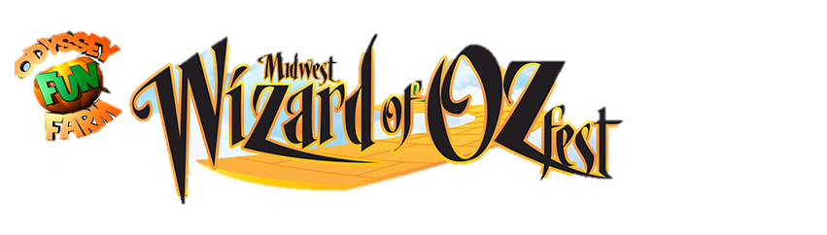
Contact Name: _______________________________________
Midwest Wizard of Oz Fest
Vendor Application
August 4-6 2017
Tinley Park, Illinois
August 4: 12pm-5pm
August 5: 10AM-6PM
August 6: 10AM-6PM
Booth/Business Name: _______________________________________
Mailing Address: ________________________________ City/State/Zip: __________________________
Email Address: ________________________________ Phone Number: _________________________
FULL Description of the products/services you will be selling or promoting in this booth:
________________________________________________________________________________________________________________________
________________________________________________________________________________________________________________________
________________________________________________________________________________________________________________________
Oz-Themed Vendor before June 30 -- $125 Oz-Themed Vendor after June 30 -- $250
Miscellaneous Vendor before June 30 -- $200 Miscellaneous Vendor after June 30 -- $300
**NOTE: Oz-Themed vendor price applies to vendors who will be selling Wizard of Oz related merchandise at his/her booth(s) throughout the festival

Specifics on acceptance: NO ELECTRIC SERVICE PROVIDED. Booth must be OPEN from the time the festival begins to the time that it closes for the day. Festival has the ABSOLUTE RIGHT to reject and remove objectionable items at their discretion. Vendor agrees to hold HARMLESS to the Odyssey Fun Farm and Odyssey Fun World establishments in all regards. Vendor is 100% responsible for the security of their booth and its contents, as well as the clean up after the event. FOOD and DRINK may NOT be sold at ANY booths, unless specifically approved by festival director beforehand.
ACCEPTANCE IS NOT GUARANTEED until you receive the official festival confirmation letter. Fee is NON-REFUNDABLE if accepted.
Please make checks payable to: Odyssey Fun World
19111 S. Oak Park Ave
Tinley Park, IL 60477
Agreement: My signature below CONFIRMS that I have read and agree with this application and its contents in FULL and agree that I will faithfully abide by it.
Signature: ________________________________________ Date: _____________________
Odyssey Fun World
19111 S. Oak Park Ave.
Tinley Park, IL 60477
Phone: (708) 429-3800 Fax: (708) 429-4078
Email: info@odysseyfunworld.com
Website: midwestozfest.com

